**ISTE 7821: Visual Analytics**

**Assignment # 1**

**Group Members:**

* Ali Khalid (ak5013)
* Kaleem Nawaz Khan (kk5271)
* Muhammad Raees (mr2714)

**Published Workbook Weblink:**

<https://public.tableau.com/app/profile/ali.khalid2234/viz/Assignment_Workbook_16755559403870/Story>

**Screenshots:**

* The screenshot below shows a chart that shows the spatial distribution of listings in San Francisco and user can hover the mouse over different listings to view information about it.

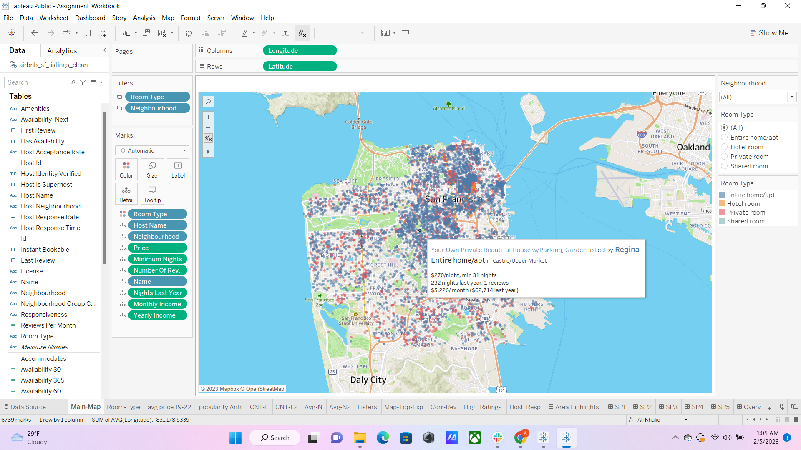

* A dashboard was created to show the ratings, price and responsiveness of different Airbnb listings. User can apply filters on price, ratings and responsiveness.

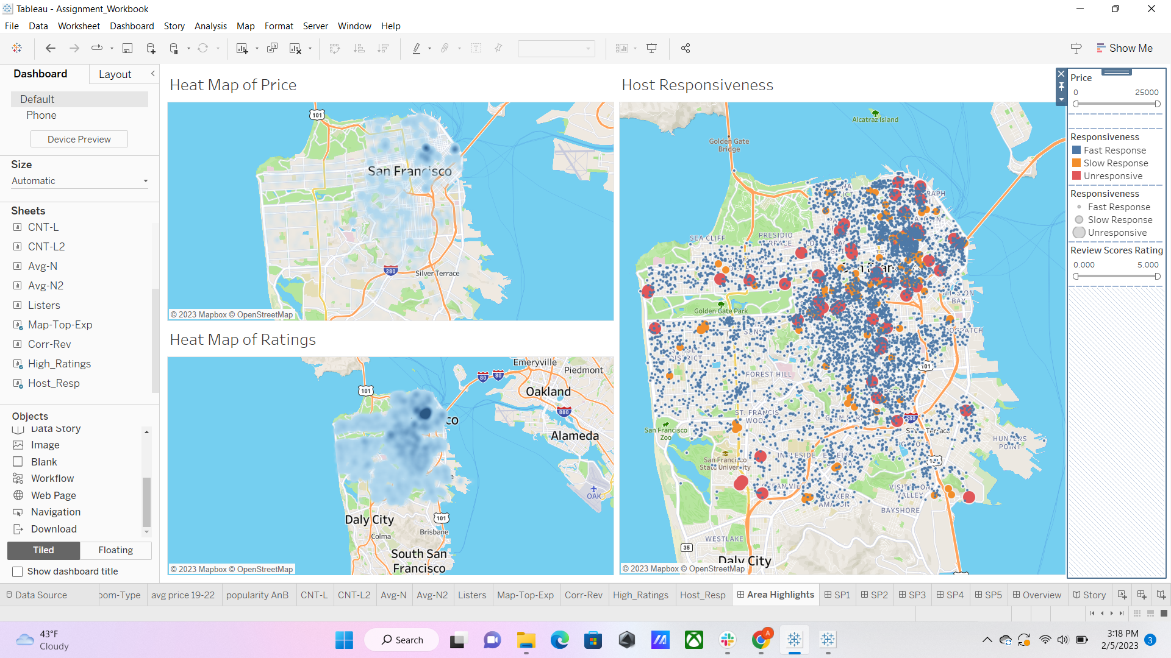

* **Tableau Design Essay:**
  1. **Tableau makes a lot of default choices. Different chart types are recommended for different types of data. How would you determine and characterize these chart types recommended? Explain. Also, do you follow any guidelines, theories or use just Show Me? Make critiques.**

The components of the graphs that we make to visualize data are not selected at random. The purpose of the graph is to convey specific information, and therefore Bertin regards graphs as monosemic systems. Moreover, the signs and symbols used in the graph have concrete meanings, and their study is referred to as the semiology of graphics. The suggestions presented by Tableau are also not random and depend a great deal on the type of data that we want to plot. Different types of charts are suitable for different types of data. For example, the bar chart is good if we want to show the distribution of some variable that can only assume discrete values, while the line chart will be more suited for a variable that can have a continuous value within a certain range. Obviously, there are always multiple ways to build a chart to display the same information; for instance, both pie charts and bar charts are good ways to represent the percentage distribution over a discrete variable. In these situations, the type of chart completely depends on the user, who typically chooses it by taking into account its viability for the specific use case or by ensuring consistency among the various charts in the same report.

We looked into Bertin's terminology and suggestions for effective graph construction and reading, and we made an effort to apply them to the visualizations we created. We begin by selecting the components to be visualized, as well as the corresponding invariants. Next, we decide what chart will best convey the component under consideration. Following that, we make sure that the axis of the charts has the units mentioned clearly. Moreover, we also equip the chart with an appropriate title and legend. Bertin only talks about static graphs, but Tableau can be used to create interactive visualizations; therefore, we also add a check box or slider to our charts in addition to the tooltip to improve the interactivity of the chart.

* 1. **What is a data visualization? Make your own definition.**

The development of a visual display, which can be interactive or static, from raw data to represent trends, properties, comparisons, or distributions of variables or groups of variables to convey information in an efficient and effective manner by leveraging computers and human visual perception is known as data visualization.

* 1. **In your opinion, what are the components or criteria of building effective and impactful interactive visualization for an average user? List them and give brief explanations. Does Tableau satisfy your components or criteria? Then, did you find any literature that discusses these components or criteria? You can refer to the papers we cover.**

Following are some of the components that we believe are necessary for creating an effective and impactful interactive visualization for the average user.

* + - **Variables:**

Variables that are used to create the graphs are of paramount impotence in understanding the information presented by the graph. Different axis in the graph represents different variables and the name of the variable should be mentioned with each axis to avoid confusion.

* + - **Units:**

The units of the variables that are represented by each axis is also important as without units information is incomplete and can result in misinterpretation. For example, if one of the axes is representing the length and the unit (like a meter or millimetre) is not mentioned then the observer will not be able to comprehend the complete information.

* + - **Title:**

Tile serves as a summary of the information that we are trying to represent in the graph. Therefore, a good title can make it very easy for the observer to understand the purpose of the graph and at the same time provide the creator of the graph with a method by which he/she can make the observer focus on a particular relationship between the variables.

* + - **Legend:**

If the data is divided into groups and the information about each group is shown by a different colour then legend guides the observer about which colour belongs to which group. Moreover, the meaning of different symbols used in the graph can also be specified in the legend